INSTRUCTIONS FOR AUTHORS

E. Scutelnicu¹, C. C. Rusu^{2*}

¹“Dunarea de Jos” University of Galati, Faculty of Engineering, Romania
²“Dunarea de Jos” University of Galati, Department of Manufacturing Engineering, Romania
47 Domneasca St., 800008 – Galati, Tel. +40336130208
*Corresponding author’s e-mail address: carmen.rusu@ugal.ro

ABSTRACT
The paper has to be sent as document Word at the e-mail address of the editor-in-chief. Please use the AWET_LAST NAME of the first author_Number of the paper.docx for the name manuscript. The abstract of 100 - 120 words should briefly describe the content of the paper. Manuscripts should have even number of pages, at least 4 pages and should not exceed 10 pages A4. Please ensure all text, figures and formulas are of high definition and good contrast. The visual quality of the journal will directly reflect the visual quality of the submitted manuscripts.

KEYWORDS: List of 5-6 keywords

1. PAPER SIZE AND MARGINS

The MARGINS of the A4-size page are: Top - 2.5 cm, Bottom - 2.5, Right - 2.5 cm, Left - 2.5 cm, GUTTER - 0 cm, HEADER - 1.25 cm, FOOTER - 1.25 cm. LAYOUT: Tick off Different odd and even and Different first page.

2. HEADER

There is no header on the first page and it is different on the odd and even pages (see the Paper Template).

3. FOOTER

The footer is different on the first page, odd and even pages. On the first page © Galati University Press, 2015, Date of submission/acceptance and the number of the page (TNR 10) is inserted.

4. TEXT

The body text should be Times New Roman 10 pt (TNR 10 pt), single spacing. All free lines will be Times New Roman 10 pt, single spacing. Tabs will be set for whole document at 0.6 cm, excepting the first paragraph within each section that has not tab set.

5. TITLE

The title should be written with capital letters, TNR 14 pt, bold, centred on the width of the first page, after three free lines TNR 10 pt from the upper margin of the paper. The title will not exceed more than three lines.
6. AUTHORS

Between TITLE and AUTHORS leave one line (TNR 10 pt). Use Courier New 12 regular, centred for the authors name (initial of first name, dot, blank space and last name having only first letter as capital letter). Between the names of the authors, commas are inserted. If the authors have different affiliation use the numbers (1, 2 etc.) and * for the corresponding author, as superscripts.

7. AFFILIATION

Between AUTHORS and affiliation there is a free line (TNR 10 pt). The affiliation will be typed on single line, using TNR 10 pt, regular, centred, capitals for initial letters.
When there are at least two affiliations, before the affiliation name will be the number of the superscript corresponding to the author’s name. After the name of the institution type a comma and the name of the country. The e-mail address of the corresponding author will be typed on the next line, using TNR 10 pt, regular centred.

8. ABSTRACT AND KEYWORDS

The section for abstract content and keywords will have indentation of 20 mm left and right, centred on the page width. The abstract of 100 - 120 words should give a brief account of the most relevant aspects of the paper (research methodology and results discussion section).
The word ABSTRACT (TNR 12 pt, bold, centred) will be preceded by 2 free lines and the content of the abstract (single spacing TNR 10, Italic, Justify) will follow immediately under the word ABSTRACT (on the next line). Between the abstract content and the word KEYWORDS: (TNR 10 pt, bold, uppercase) there is a free line (TNR 10 pt). After the word KEYWORDS: write on a single line a list of 5-6 keywords (or groups of keywords).

9. PAPER BODY TEXT

Manuscript will be typed in two equal columns (6 mm between columns), fully justified, after two free lines (TNR 10 pt) from KEYWORDS line. The characters will have TNR 10 pt, regular, single spacing. Please, pay attention to balance the columns on the last page of the paper.

10. MAJOR HEADINGS AND
SUBHEADINGS

For all headings, Arabic numbers should be used followed by a dot and a blank space. Number of subheadings includes the number of the major heading, dot, the subheading 1 number, dot (if necessary, insert the subheading 2 number, dot) and blank space.
Major headings must be typed in capitals, TNR 11 pt, bold, aligned left in the column. Leave a space of one line (TNR 10 pt) above and one line (TNR 10 pt) below these headings.
Subheadings 1 should be typed TNR 11 pt, bold and aligned left in the column (Title Case). Leave a space of one line (TNR 10 pt) above and one line (TNR 10 pt) below.
Subheadings 2 should be typed TNR 10 pt, bold and italic and aligned left in the column (Title Case). Leave a space of one line (TNR 10) above and one line (TNR 10 pt) below these hadings.

11. FOOTNOTE

Footnote will be typed TNR 9 pt, regular, single spacing, justified, at the bottom of the page including the word or group of words there is referred to, and after a line of 1.5 pt (based on Word feature). Within the body text, the footnote will be indicated by an Arabic number typed as superscript. The footnote text begins with the number associated in the body text.

12. FIGURES/ILLUSTRATIONS

All figures, photographs and illustrations should be in greyscale, legible and rich in contrast and should be placed as close as possible to their mention in text (if it is not possible, group them at the end of the page where there are mentioned). Scanned images can be used if the output resolution is at least 300 dpi. Do not submit poor reproductions.

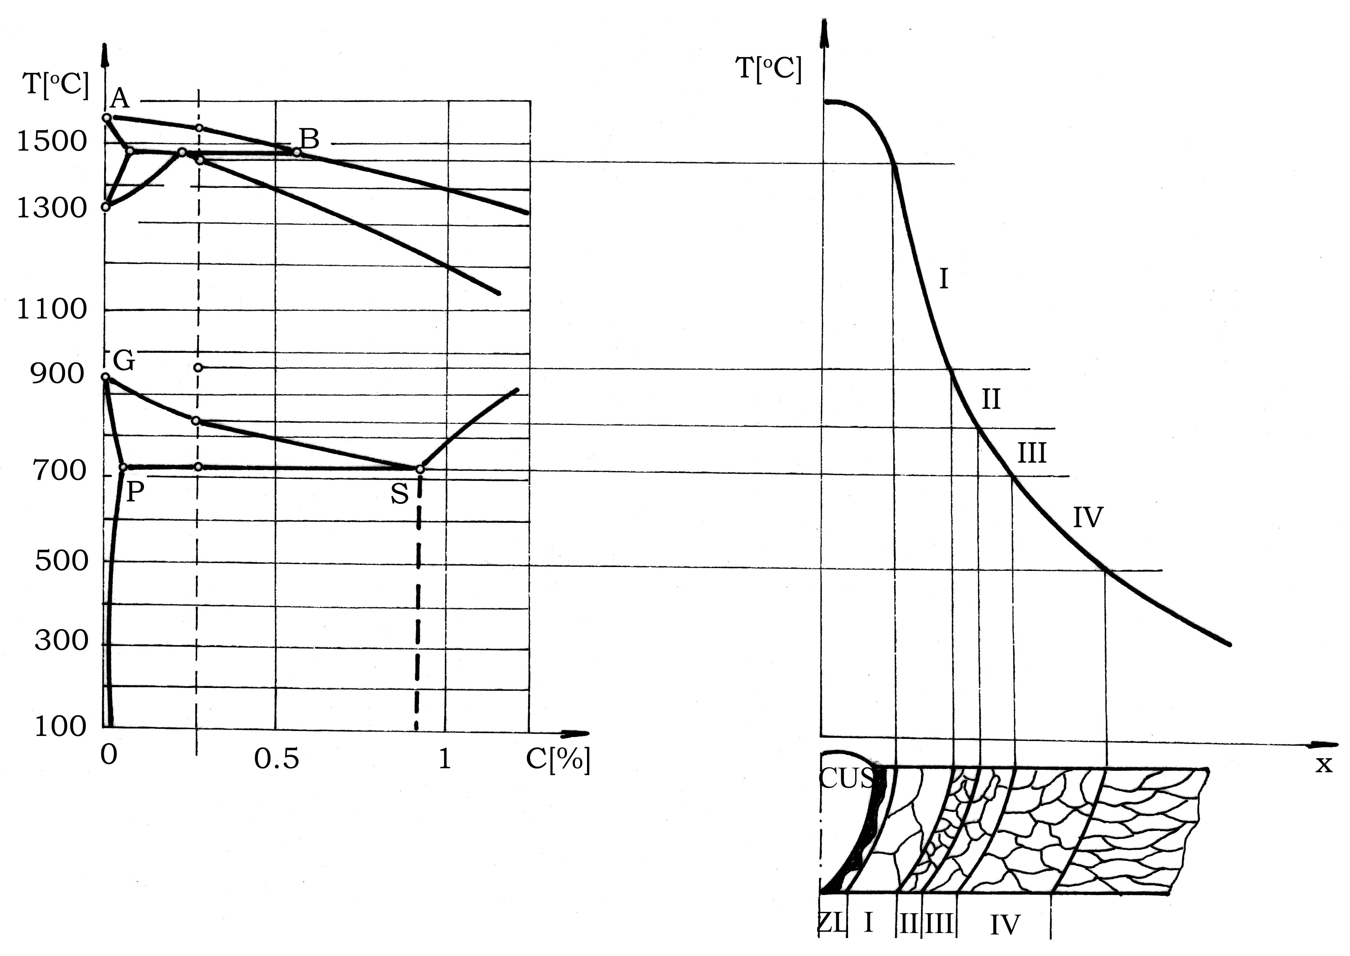

Fig. 1. Example of embedded figure

A figure larger than a single column should not be reduced to fit; use two columns instead, preferably at the top of the page. Under each figure, it will be typed Fig., blank, the Arabic number of the figure, dot (TNR 10, bold) and blank space followed by a short explanation (starting with capital letter, TNR 10, regular, centred). For illustrations wider than a column, a single page may be used (eventually Landscape).
Reference within the text will be done using Figure x at the start of the sentence, figure x within the text or (Fig. x) at the end of the sentence. Lettering within all illustrations should be of size which is legible.

13. TABLES

All tables must be created using Table utility provided by Microsoft Word. Information within the table will be written using TNR 10 pt, regular, single spacing.
A table wider than a single column should not be reduced to fit; use two columns instead, preferably at the top of the page. For tables larger than a column, a single page may be used (eventually Landscape).
Refer to tables as Table x (number) in the text. Table will be simply framed (bordered) using line of 1/2 pt. Before the table, insert the word Table, blank space, the number of the table with Arabic number, dot (all written with TNR 10, bold), blank space and the title of the table (starting with capital letter, TNR 10 pt, regular and center aligned). Leave a space of one line (TNR 10) after the title of table.

14. SYMBOLS AND ACRONYMS

Use ISO standard symbols and unit abbreviation. International Systems Units (SI units) is compulsory. Define any acronym the first time it appears within the text. For paper, including many symbols, it is recommended to have a list of definitions at the end of the paper.

15. TERMINOLOGY

Because welding cuts across many different scientific disciplines, various standards of technical usage can be applied. For welding terminology use AWS Standards. For usage not covered by these standards, authors are encouraged to apply the recognized standards of the discipline involved.

15.1. AWS Terminology

ANSI/AWS A3.0-01, Standard Welding Terms and Definitions includes approved terminology and process abbreviations and must be used. A list of some of the more commonly used terms showing standard and non-standard forms is given below.

Table 1. AWS terminology

Standard | Non-standard
arc welding | electric arc welding; electric welding
base metal (material) | parent metal, base plate
brazing filler metal | hard solder
butt joint | butt weld
complete joint penetration | complete penetration, full penetration
covered electrode | coated electrode, stick electrode
diffusion brazing, diffusion welding | diffusion bonding
filler metal | filler alloy
gas metal arc welding (GMAW) | metal inert gas (MIG); CO2 welding
gas tungsten arc welding (GMAW) | tungsten inert gas (TIG)
groove radius | root radius
incomplete fusion | lack of fusion
oxygen cutting | flame cutting; burning
residual stress | locked-up stress; shrinkage stress
root face | land, nose
root opening | root gap
shielded metal arc welding | stick electrode welding
solder | soft solder
welding torch or cutting torch | blowpipe (except in brazing and soldering gas torch)
welding wire | wire, filler wire

16. EQUATIONS

Equations should be created using Equation Editor from Microsoft Word. When numbering the equations, enclose its corresponding Arabic number in round parenthesis and align the number at right. The equation will be centred on the line.
Examples of a one-column and two-columns (when the equation exceeds the width of one column) equations:

(1)

(2)

Table 2. Editing instructions for equation

Style/Define | Size/Define
Text: TNR, Italic; | Full: 10 pt  Subscript / Superscript: 8 pt  Sub-Subscript / Superscript: 7 pt  Symbol: 14 pt  Sub-symbol: 7 pt
Function TNR Italic; Variable: TNR Italic
LC Greek: symbol
UC Greek: symbol
Symbol: symbol

Matrix vector: Times New Roman, bold

Number: TNR, Italic

17. CONCLUSIONS

The conclusions of the research should be clearly defined in the CONCLUSIONS section. The CONCLUSIONS title should be numbered, written with TNR 11 pt, bold, capital letters.

APPENDIX

The appendix text will have the title APPENDIX X (number of explanation) written as a major heading (TNR 11 pt bold, centred, one free line up and down the word APPENDIX).

ACKNOWLEDGEMENTS

It has to be written just before REFERENCES, in the two-column text, not separately from the body text of the paper. The word Acknowledgements will be typed as a major heading (TNR 11 pt, bold, centred, one free line up and down the word ACKNOWLEDGEMENTS), no numbered.
Acknowledgements may be made to individuals or institutions, not mentioned elsewhere in the paper, that have made an important contribution.

REFERENCES

The word REFERENCES will be typed as a major heading (TNR 11pt, bold, centred, one free line up and down the word REFERENCES), no numbered. All information will be TNR 8 pt, regular, single spacing and will contain: number of the references; last name followed by the initial of first name for each author (bold), full paper title (italic), title of journals/ proceedings/books, ISSN/ISBN, publisher or institution name, city, year of publication, first and last page of the paper, separated by a dash.
The authors should include at least 6 items in the references list. Please don’t use the own quotations. Taking into account the last name of the first author, the references will be organised in alphabetic order (see the examples from below). No tab or indentation will be used for typing. All references should be compulsory cited in text. In the body text of the paper the references will be done by their number, typed in brackets [x]. In the case of two citations, the numbers should be separated by comma [x], [y]. In the case of more than two references, continuously numbered, the numbers should be separated by a dash [a]–[d].
The name of the references, journals and publishing house will be written in the language used for editing, an eventual translation into English may be put in round parenthesis, after the original name. The texts including non-Latin words will be transliterated as recommended by the international standards.
- Dilthey U., Ulrico K., GMA-Brazing of Galvanized and Alloyed Steels, IIW Doc. XII-1630-00, Welding Institute, Aachen University, Germany, 2000.
- Faerber M., Process Gases for Laser Welding, Proceedings of CISFFEL, Toulon, 1998, pp. 837-841.
- Khandkar M.Z.H., Khan J.A., Reynolds A.P.: Prediction of temperature distribution and thermal history during friction stir welding: input torque based model, Science and Technology of Welding and Joining, vol. 8, no. 3, 2003, pp. 165-174.

Radaj D., Heat effects of welding: temperature field, residual stress, distortion, Springer-Verlag Berlin Heidelberg, Germany, 1992.

PLEASE NOTE

Full responsibility for the paper rests on the author. You must have taken the necessary steps to obtain permission for using any material that might be protected by copyright. Statements and opinions advanced in published papers are understood to be individual expressions of the authors and not those of the journal editor.
Reviewers and editors may suggest some changes. Corrections to the paper cannot be undertaken by the Publisher or the Editors. You will receive reviewing and editing notes by e-mail one month after the paper submission date. The final form of the paper must be received by e-mail, in two electronic formats: Word and Adobe Acrobat.

THE CHECKLIST

To avoid overlooking important details, authors are requested to execute the checklist supplied with these instructions and suggestions.
Subject Matter: Papers should give new facts, new methods, experimental results or important conclusions about design, processes, techniques, construction, operation, maintenance, safety or related subjects.
Title: Not more than ten words may be used.
Heading and Subheadings: Several headings (subheadings, if needed), should be used throughout the text to divide subject matter into its important, logical parts.
Length of Manuscript: Length of manuscript (even number of pages) should not exceed 10 pages.
Number of Figures: A well balanced paper contains approximately two illustrations for each 1.000 words.
Referencing of Figures: All illustrations must be sequential marked by a figure number and called out in the text, by figure number.
Photographs: Photographic prints should be clear and sharp, with glossy finish.
Line Drawings, Graphs, etc.: Do not submit poor reproductions. Use at least resolution of 300 dpi for figures, graphs, photographs, illustrations etc.
Standard Terminology, Symbols, Trade names, etc.: Terms and definitions standardized by the American Welding Society must be used.

